**Lesson 8 Demo 2**

**Performing CRUD Operation on Containers**

Steps to be followed:

1. Pulling a Docker image
2. Creating a new container
3. Stopping the container
4. Listing all the containers
5. Deleting the container
6. Removing the image

**Step 1: Pulling a Docker image**

1.1 Open the terminal and pull an image using the command:

***sudo docker pull nginx***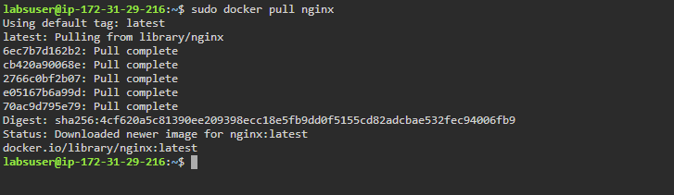

1.2 List all the docker images to check the newly pulled *nginx* image:

***sudo docker images***

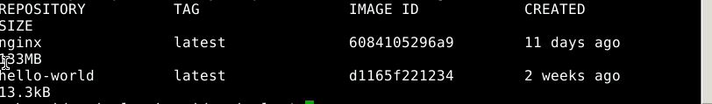

**Step 2: Creating a new container**

2.1 Create a new container from the *nginx* image:

***sudo docker run -dt -p 80:80 nginx***

2.2 List all the running containers to check the newly created container. You can find various details like port of container, it’s time of creation and ID.

***sudo docker ps***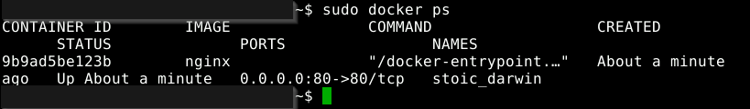

**Step 3: Stopping the container**

3.1 Use the following command to stop the running container. ***(***You can also us the container ID to stop the container: *sudo docker stop CONTAINER_ID****)***

***sudo docker stop CONTAINER_NAME***

3.2 Use the following command to list all the running containers and verify if the container has stopped running:

***sudo docker ps***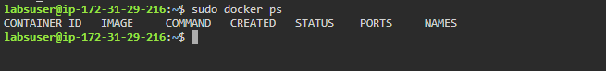

3.3 You can start the container again and check the running containers. ***(***You can also us the container ID to start the container: *sudo docker start CONTAINER_ID****)***

***sudo docker start CONTAINER_NAME***

***sudo docker ps***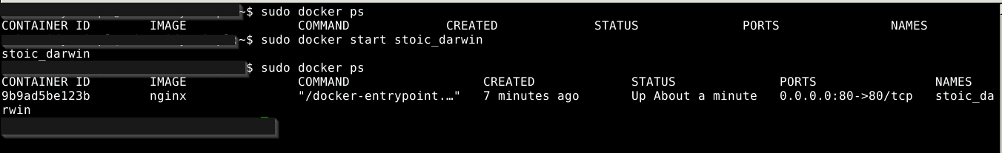

3.4 To start the container in interactive mode, use the –i and –t options.

***sudo docker run -it –name=Test_1 ubuntu***

**Step 4: Listing all the containers**

4.1 Use the below command to list all the containers started and the once which are stopped:

***sudo docker ps -a***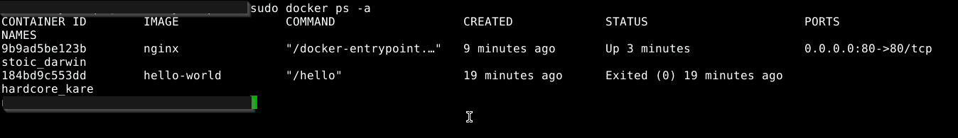

4.2 To list the containers by their ID, use the below command

***sudo docker ps -aq***

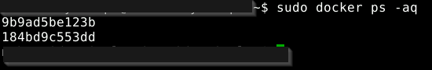

You can see the containers with ID are listed.

4.3 To list the total file size of each container, use the below command:

***sudo docker ps -s***

4.4 To list the latest created containers, use the following command:

***sudo docker ps -l***

**Step 5: Deleting the container**

5.1 Stop the running container and remove it using the following commands:

***sudo docker stop CONTAINER_NAME***

***sudo docker container rm CONTAINER_NAME***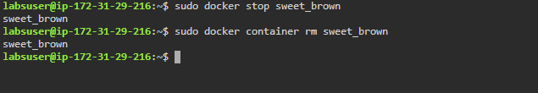



**Step 6: Removing the image**

6.1 Remove the image using the command:

***sudo* *docker image rm nginx***

